Map the elements from the evidence table above into the diagram below (type in the blue boxes - click and drag to rearrange them). The brackets you used earlier to indicate weak positive or negative indicators will help you place them more precisely. Underline POSITIVE evidence to help differentiate it from the negative.
RELATIONSHIP

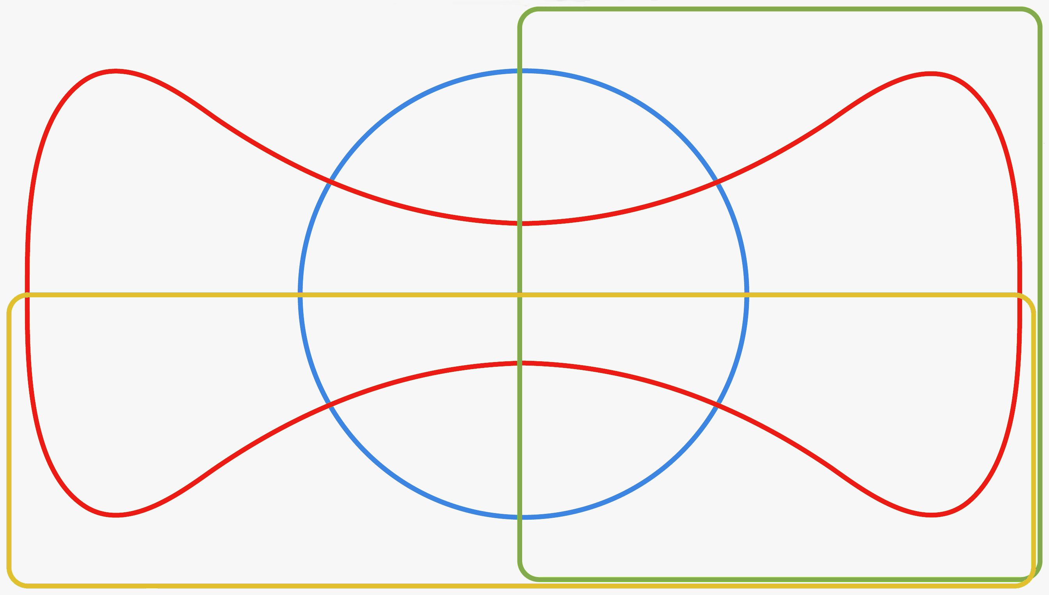
DIAGNOSTICS
MANAGEMENT
PROFESSIONALISM
- Look at each domain shape in turn: which R, D, M and p themes dominate?
- Then explore these with the trainee using ‘SKIPE’

